As a sailor you need to know everything about the ship to do your job. Can you match the different parts of the ship? Look back at the video to help you label the different parts of the ship.
9
8
7
5

6

________ Main Deck (also known as amidship): primary area of the ship deck; in the middle of the ship.

________Fore Mast: The mast closest to the ship’s bow.

________Jib: the sail that the farthest forward; a part of the headsails

________Quarterdeck (also known as stern): the deck farthest aft on the boat with the helm; below the
deck is the captain’s quarters.

________Fore Sail: The sail attached to the forward mast; the sail is raised over the main deck.

________Main Mast: Mast typically located in the middle of the ship; holds the heaviest sail.

________Staysail: the sail closest to the foredeck, also part of the headsails.

_______Main Sail: The heaviest sail on the ship, attaached to the main mast.

_______Fore Deck: The deck at the very front of the ship (the bow)

Everything sailors needed for a voyage needed to be on board before they left port. Spirit of Dana Point is a replica of a ship from the late 1700s. What items would you find on board a ship from the 18th or 19th century?

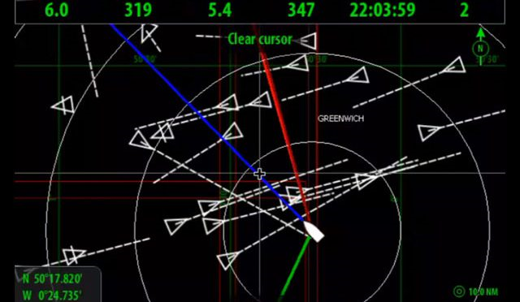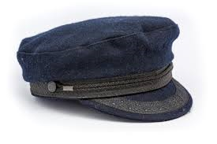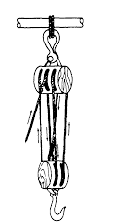

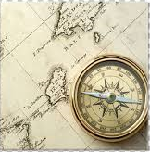

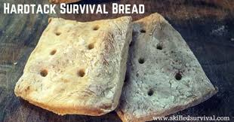

You decide to sign aboard the Spirit as a sailor. You have none of the items you need for life at sea. When you get to the store, you realize you cannot buy everything with the 20 dollars you have.

Working Shirt: $3
Warm Coat: $10
Boots: $5
Trousers/pants: $4
Rigging Knife: $8

What items did you buy with your 20 dollars? How much did it cost?

Why did you choose to buy those specific items?

What items are you missing?

How will not having those items affect your voyage as a sailor?

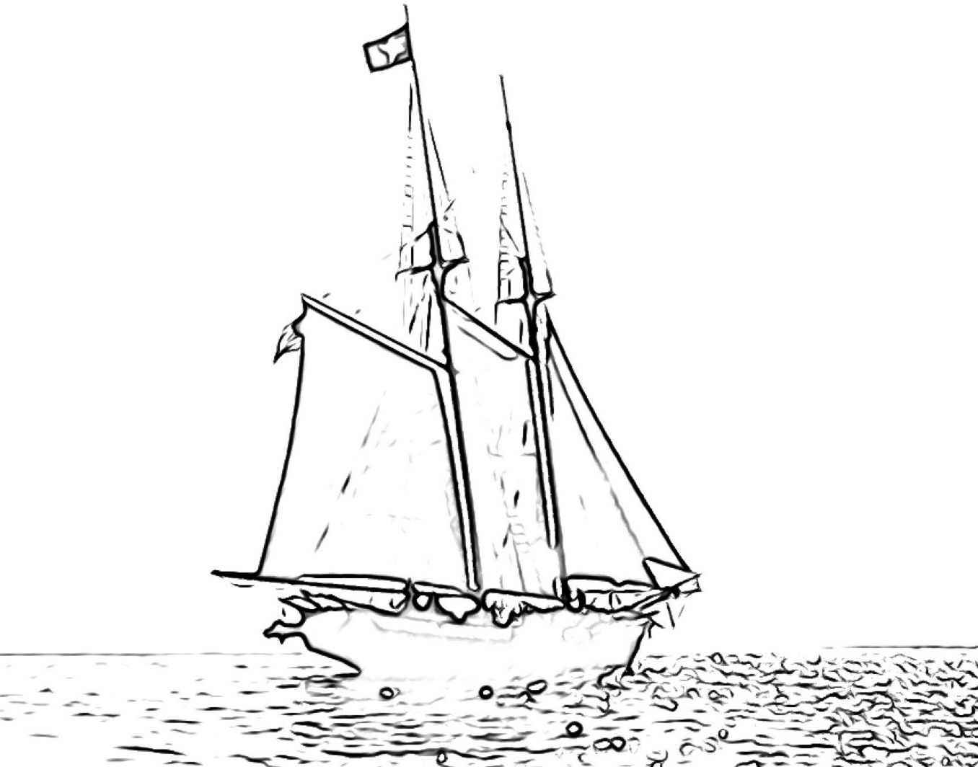
Draw yourself as a sailor below with the items you bought for your voyage at sea.

