As a sailor you need to know everything about the ship to do your job. Can you match the different parts of the ship? Look back at the video to help you label the different parts of the ship.
9
8
7
5

6

________ Main Deck (also known as amidship): primary area of the ship deck; in the middle of the ship.

________Fore Mast: The mast closest to the ship’s bow.

________Jib: the sail that the farthest forward; a part of the headsails

________Quarterdeck (also known as stern): the deck farthest aft on the boat with the helm; below the
deck is the captain’s quarters.

________Fore Sail: The sail attached to the forward mast; the sail is raised over the main deck.

________Main Mast: Mast typically located in the middle of the ship; holds the heaviest sail.

________Staysail: the sail closest to the foredeck, also part of the headsails.

_______Main Sail: The heaviest sail on the ship, attaached to the main mast.

_______Fore Deck: The deck at the very front of the ship (the bow)

Friday May 22nd is National Maritime Day recognizing the importance of maritime industry in America since the American Revolution. The holiday is on May 22nd to commemorate the American steamship Savannah’s voyage from the United States to England, marking the first successful crossing of the Atlantic Ocean with steam propulsion in 1819.

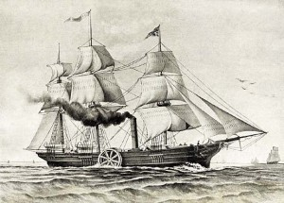

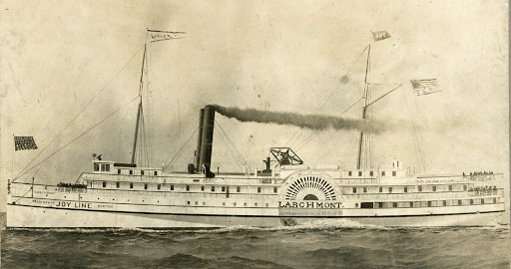

Steamship Savannah

How did the invention of steam engine transform the maritime industry and trade?

The Savannah was originally a traditional sailing ship. In 1818, they added a steam engine for its historic voyage in 1919. What were the benefits of being powered by both wind power and the steam engine?

The steamship Savannah used coal as the fuel source. What are the dangers of a steam engine and environmental impact?

The process of building a boat has been transformed throughout the centuries due to the different materials available and the development of new technologies. Boats have been built out of wood, different types of metals, and fiberglass. What are the pros and cons of using each material for boat building?

 | Wood | Metals (steel, aluminum, bronze etc) | Fiberglass
Pros
Cons

You are a built builder and have an unlimited budget. Using the pros & cons from chart above what materials would you use and why? Are there any other environmentally friendly materials that would fix the cons from above? Design your boat below utilizing the materials you think would be the most efficient for a modern boat.

