As a sailor you need to know everything about the ship to do your job. Can you match the different parts of the ship? Look back at the video to help you label the different parts of the ship.
9
8
7
5

6

________ Main Deck (also known as amidship)

________Fore Mast

________Jib: the sail that the farthest forward; a part of the headsails

________Quarterdeck (also known as stern)

________Fore Sail

________Main Mast

________Staysail: the sail closest to the foredeck, also part of the headsails.

_______Main Sail

Everything sailors needed for a voyage needed to be on board before they left port. Spirit of Dana Point is a replica of a ship from the late 1700s. What items would you find on board a ship from the 18th or 19th century?

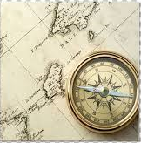
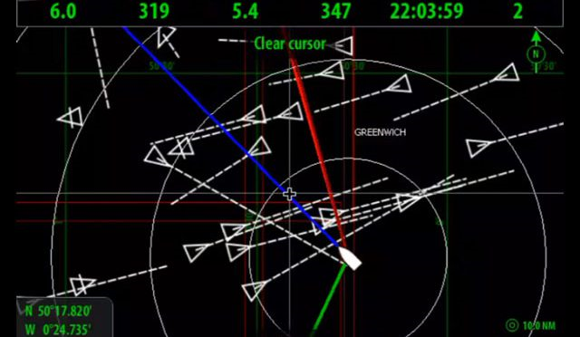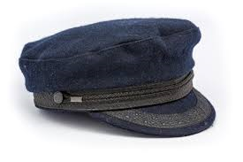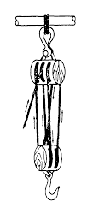

You decide to sign aboard the Spirit as a sailor. You can only bring 5 items from home with you on your voyage. What do you bring and why?

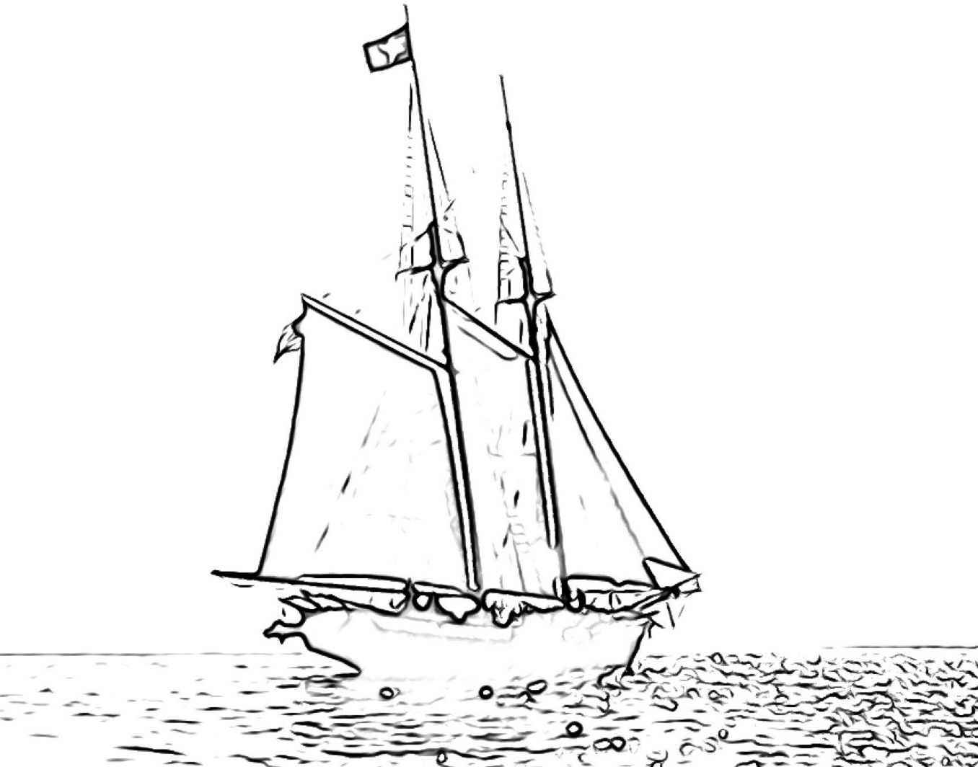
Draw yourself as a sailor below, in traditional sailor clothing, with some of your personal items at sea.

