1. Color your moon jelly however you would like and label the moon jelly using the words right below. Look back on the video to hear Andrea talk about jelly anatomy.

Bell Stomach Oral Arms Tentacles

2. There are many different types of jellyfish in the ocean. Just look at a few below! Write down at least one thing you notice about each jelly you see. Write what you notice in the lines below each picture.
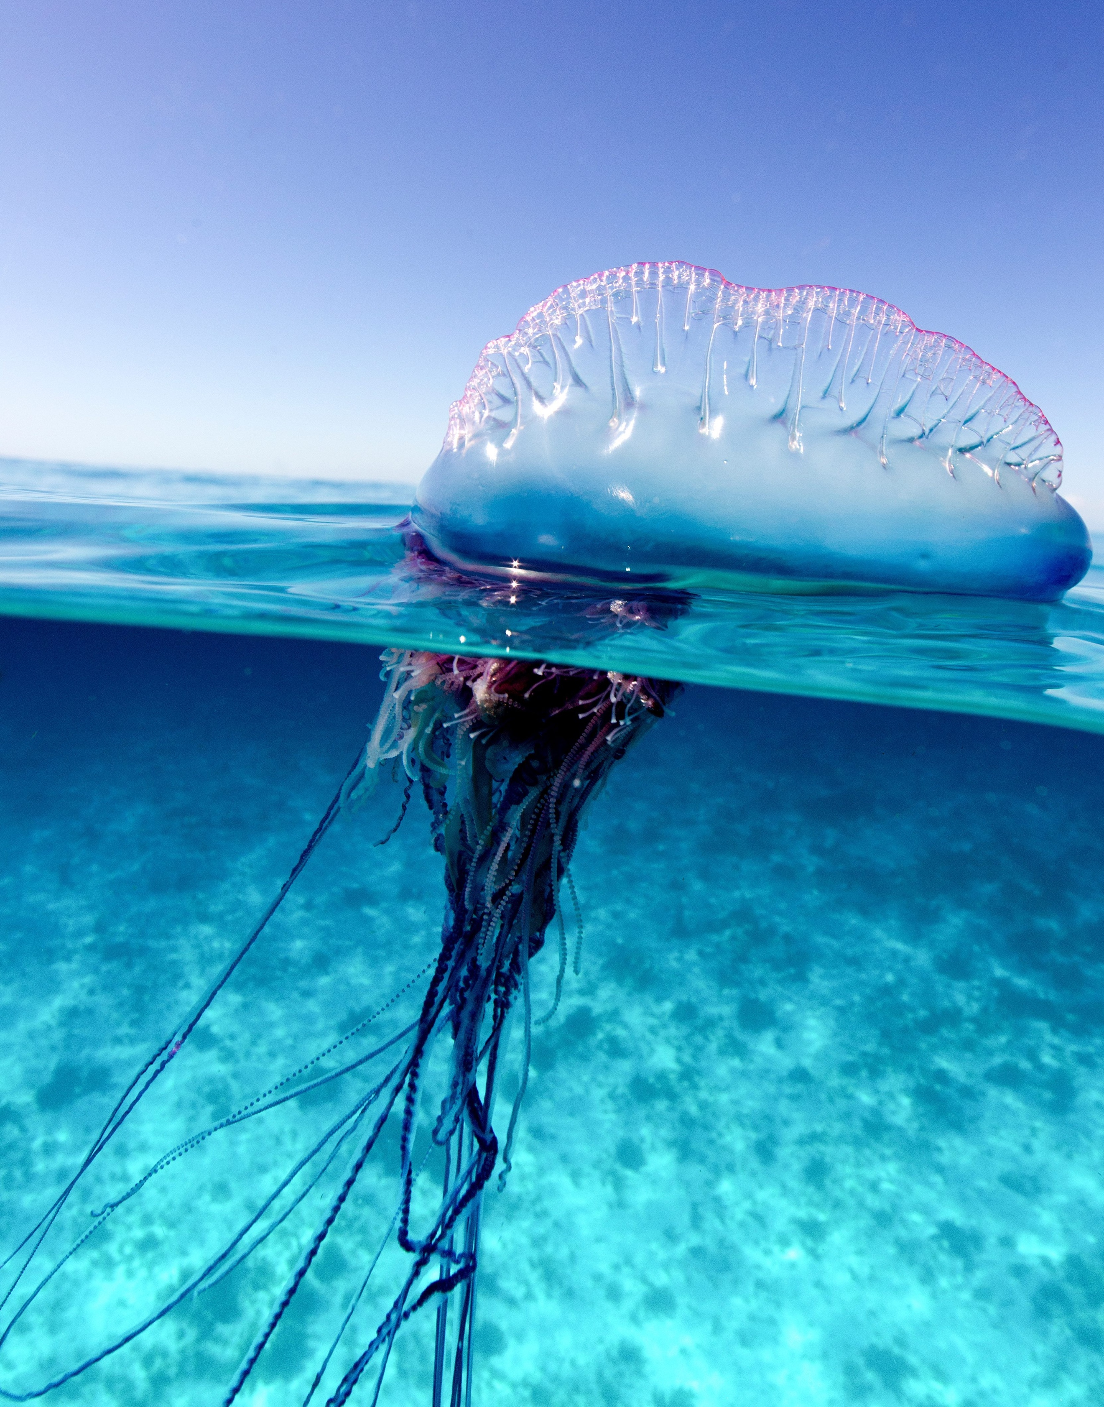
Moon Jelly
Man-of-War Jelly

I notice…
I notice…
I notice…

__________________________________
Compass Jelly

__________________________________

__________________________________
Barrel Jelly

I notice…

__________________________________

3. Jellyfish are not actually fish… they are PLANKTON! Plankton are floating, drifting animals in the ocean that are not strong enough to swim against the moving water of the ocean, so they float around freely. Jellyfish don’t have bones either! Even though fish have bones, jellies are not fish, so they do not have bones.

What more do you want to know about jellies? Write down three questions that you have about jellyfish.

1.

2.

3.

4. Answer the questions below using this beautiful picture of different jellies!

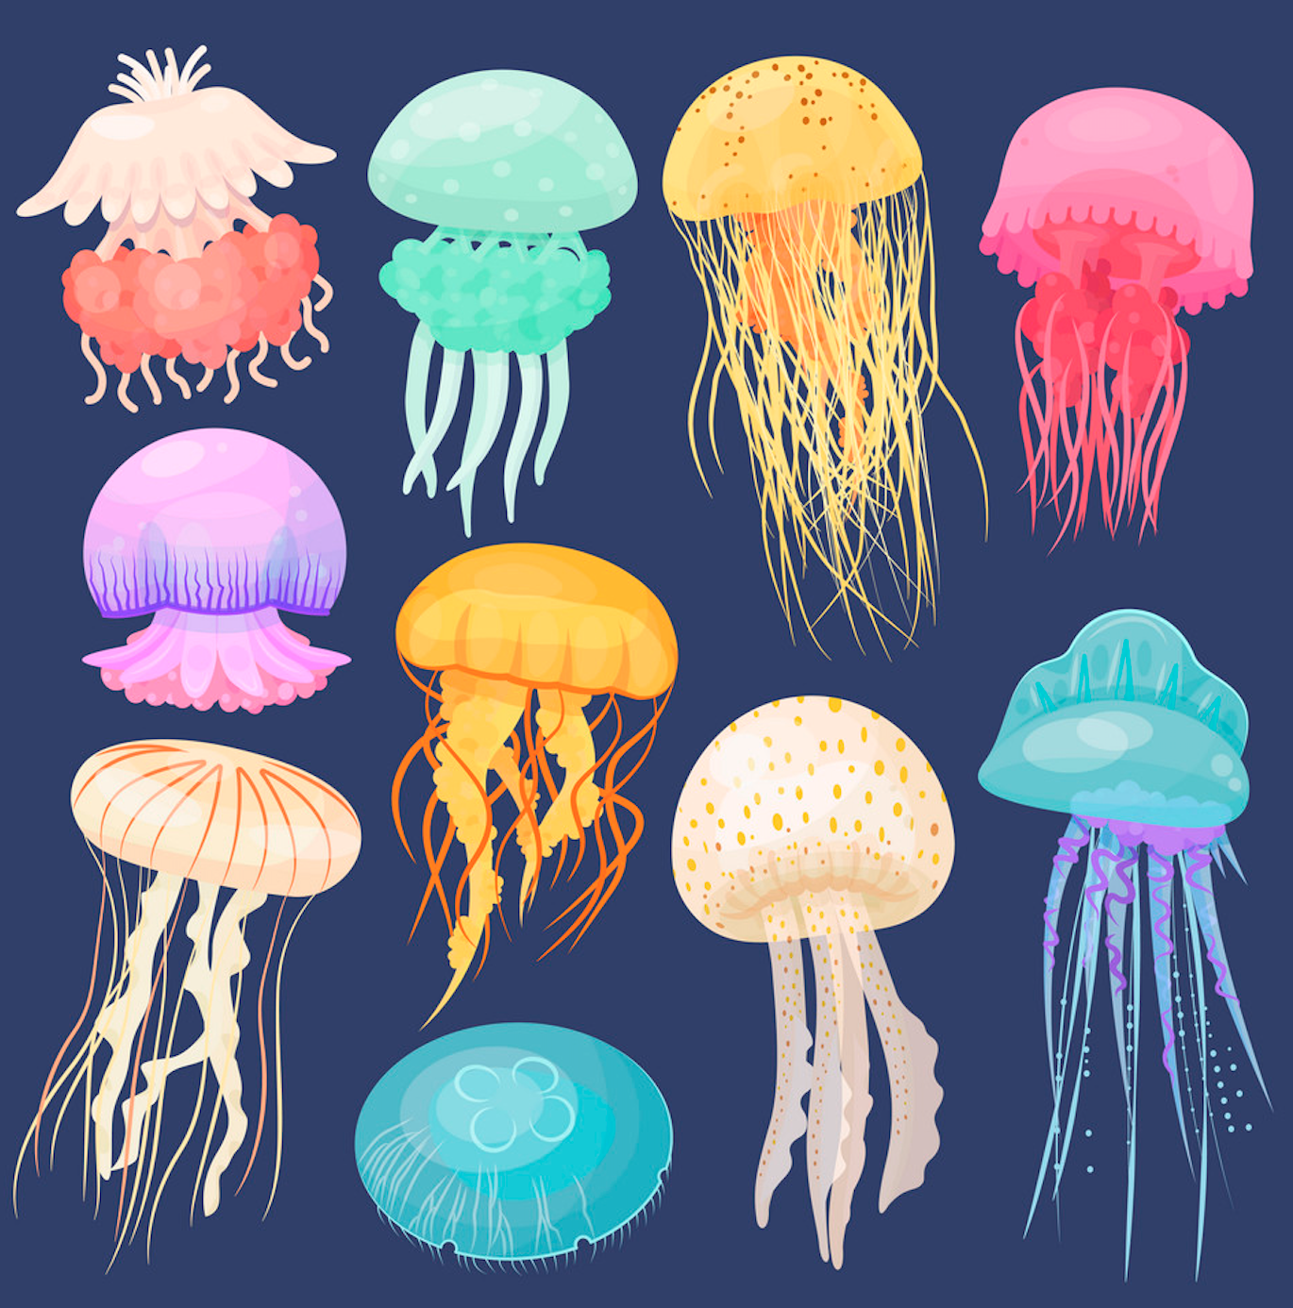

How many orange jellies are there? _______

How many blue jellies are there? _______

Which color is there the LEAST of? _______

Which color is there the MOST of? _______

Circle your favorite jelly and write down why- ________________________________________

______________________________________________________________________________

